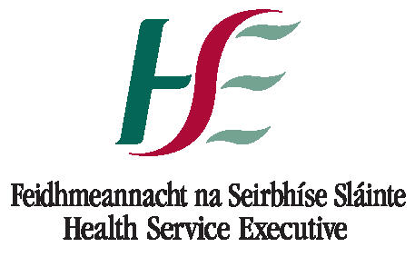
News Release
Health Service Executive

An Invitation to Remember…….

Cork University Maternity Hospital will be holding their annual Service of Remembrance on Friday 10th October, 2014 at 7.30pm in the Sacred Heart Church, Western Road, Cork for anyone who has experienced pregnancy or infant loss.

We warmly welcome all parents and families who have experienced the death of a baby – this includes miscarriages, stillbirths, neonatal and infant deaths.

Light refreshments will be served after the service and there will be an opportunity to meet the hospital staff and other parents.

Daniel Nuzum, Hospital Chaplain, said ‘The death of a baby before or after birth is a devastating experience for parents and family members. Our multi-denominational Service of Remembrance is an important part of our ongoing care and support when we as a hospital community gather with parents and families to remember your baby, to offer support and to comfort one another during what is a very gentle and moving ceremony. During the service of readings and music, there will be an opportunity to light a candle in memory of your baby, write an inscription in our Book of Remembrance and to spend some reflective time with others who share in your journey.’

If further information is required please contact Daniel Nuzum, on behalf of the Pregnancy Loss Service @ 021 4920500

Ends…

For further information please contact:
National Communications Unit
HSE South.
Tel.: (021) 4928523 / 4
E-mail: communications@hse.ie

