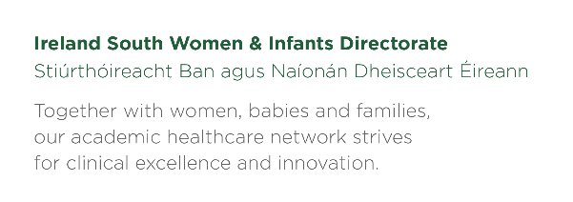

PLEASE REMEMBER TO BRING YOUR BLOOD GLUCOSE METER TO EVERY ANTENATAL APPOINTMENT

Blood Glucose level

Name________________ MRN____________

Week Commencing______________

Day | Fasting | Post breakfast 2 hrs | Pre Lunch | Post lunch 2 hrs | Pre dinner | Post dinner  2 hrs | Pre Bed
Monday
Tuesday
Wednesday
Thursday
Friday
Saturday
Sunday

Target levels; pre meals less than 5mmol
2 hrs post meals less than 7mmol
Diabetes number; 086 7872434 please phone once weekly Monday – Thursday 09.00-12.30
If you do not get a reply please leave a message.

Monday  Breakfast:  Snack:  Lunch:  Snack:  Dinner:  Snack: | Tuesday  Breakfast:  Snack:  Lunch:  Snack:  Dinner:  Snack:
Wednesday  Breakfast:  Snack:  Lunch:  Snack:  Dinner:  Snack: | Thursday  Breakfast:  Snack:  Lunch:  Snack:  Dinner:  Snack:
Friday  Breakfast:  Snack:  Lunch:  Snack:  Dinner:  Snack: | Saturday  Breakfast:  Snack:  Lunch:  Snack:  Dinner:  Snack:
Sunday  Breakfast:  Snack:  Lunch:  Snack:  Dinner:  Snack: | Notes

